1. **Project Detail**

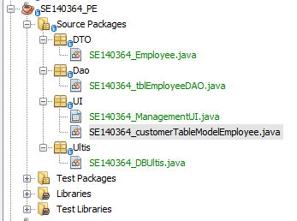

1. **Source Code**
2. **Demo**